**CHAPTER 1**

**THE PROBLEM AND ITS SCOPE**

**INTRODUCTION**

**Rationale of the Study**

Now a days, wireless fidelity or “Wi-Fi” has a great usage in using and accessing the internet. Wi-Fi is a wireless local area network connection that enables wireless devices like cell phones and laptops to connect to a network. People who have gadgets like smart-phones, laptops, android phones and even IOS phones want to connect to Wi-Fi, if there is an available connection, At times but, some routers are configured and secured with a key. Owners want to secure their connection as private and they want fast response from their service provider. When other people connect to the router, the connection speed of the router is divided to all which cause traffic to the network. There are some people who know the passkey of the router and share it to other which are a great disadvantage to the owner. Philippines cannot apply free Wi-Fi to public, unlike other countries, because the owners of the network connections pay high rate.

Wi-Fi can be less secured than wired connections (such as Ethernet) because an intruder does not need a physical connection. Web pages that use SSL are secured, but unencrypted internet access can easily be detected by intruders. Because of this, Wi-Fi has adopted various encryption technologies. The early encryption Wired Equivalent Privacy (WEP) is proven easy to break. Higher quality protocols as Wi-Fi Protected Access (WPA) and Wi-Fi Protected Access II (WPA2) were added later. These are the common problems of the users of unknown users.

The “Coin Operated Wi-Fi” is a system that will give fairness to the users of the internet. It will help people connect their devices to the internet from a private network with the price that people will agree with. It gives people different ways of payment like hourly, daily and monthly to suit their needs. Owners can also manage this system remotely from their computer so that updates can be managed securely from the public. This will be of help to the needs of some people in connecting to secure wireless local area network(WLAN) and gives the owner the right for his router or service provider. People will be able to use a system with the satisfaction of service in accordance to the price.

**Theoretical Background**

The following theories support the designed solution of the team. It contributes a massive thought to the development of the team’s project design.

Database theory

Database theory encapsulates a broad range of topics related to the study and research of the theoretical realm of [databases](http://en.wikipedia.org/wiki/Database) and [database management systems](http://en.wikipedia.org/wiki/Database_management_system).

Theoretical aspects of data management include, among other areas, the foundations of query languages, [computational complexity](http://en.wikipedia.org/wiki/Computational_complexity) and [expressive power](http://en.wikipedia.org/wiki/Expressive_power) of queries, [finite model theory](http://en.wikipedia.org/wiki/Finite_model_theory), database design theory, [dependency theory](http://en.wikipedia.org/wiki/Dependency_theory_%28database_theory%29), foundations of [concurrency control](http://en.wikipedia.org/wiki/Concurrency_control) and [database recovery](http://en.wikipedia.org/w/index.php?title=Database_recovery&action=edit&redlink=1), [deductive databases](http://en.wikipedia.org/wiki/Deductive_database), [temporal](http://en.wikipedia.org/wiki/Temporal_database) and [spatial databases](http://en.wikipedia.org/wiki/Spatial_database), [real time databases](http://en.wikipedia.org/wiki/Real_time_database), managing uncertain data and [probabilistic databases](http://en.wikipedia.org/wiki/Probabilistic_database), and Web data.

The central focus of database theory is an understanding the complexity and power of query languages and their connection to [logic](http://en.wikipedia.org/wiki/Logic). Starting from relational algebra and first-order logic (which are equivalent by [Codd's theorem](http://en.wikipedia.org/wiki/Codd%27s_theorem)) and the insight of important queries such as [graph reachability](http://en.wikipedia.org/w/index.php?title=Graph_reachability&action=edit&redlink=1) are not expressible in this language, more powerful language based on [logic programming](http://en.wikipedia.org/wiki/Logic_programming) and [fix point logic](http://en.wikipedia.org/w/index.php?title=Fixpoint_logic&action=edit&redlink=1) such as [data log](http://en.wikipedia.org/wiki/Datalog) were studied. Another focus is on the foundations of [query optimization](http://en.wikipedia.org/wiki/Query_optimization) and [data integration](http://en.wikipedia.org/wiki/Data_integration). Here most work studied [conjunctive queries](http://en.wikipedia.org/wiki/Conjunctive_query), which admit query optimization even under constraints using the [chase](http://en.wikipedia.org/wiki/Chase_%28algorithm%29) algorithm.

(http://en.wikipedia.org/wiki/Database_theory)

Database theory will be used in the project since it is efficient and the project has a query system. The Database theory has also languages or commands that make the data manageable and secured. Database theory is also involved in the recovery of data in the near future.

Systems theory

Systems theory is an interdisciplinary theory about the nature of complex systems in nature, society, and science, and is a framework by which one can investigate and/or describe any group of objects that work together to produce some result. This could be a single organism, any organization or society, or any electro-mechanical or informational artifact. As a technical and general academic area of study it predominantly refers to the science of systems that resulted from Bertalanffy's General System Theory (GST), among others, in initiating what became a project of systems research and practice. Systems theoretical approaches were later appropriated in other fields, such as in the structural functionalist sociology of Talcott Parsons and Niklas Luhmann.

(<http://www.environment.gen.tr/general-systems-theory/137-what-is-systems-theory.html>

System theory is used in this project since it has a framework of different complex components by which the team can investigate.

Policy Routing Theory

Routing is the process of selecting best paths in a network. In the past, the term routing was also used to mean forwarding network traffic among networks. However this latter function is much better described as simply forwarding. Routing is performed for many kinds of networks, including the [telephone network](http://en.wikipedia.org/wiki/PSTN) ([circuit switching](http://en.wikipedia.org/wiki/Circuit_switching)), [electronic data networks](http://en.wikipedia.org/wiki/Computer_network) (such as the [Internet](http://en.wikipedia.org/wiki/Internet)), and [transportation networks](http://en.wikipedia.org/wiki/Transport_network). This article is concerned primarily with routing in electronic data networks using [packet switching](http://en.wikipedia.org/wiki/Packet_switching) technology.

In packet switching networks, routing directs [packet forwarding](http://en.wikipedia.org/wiki/Packet_forwarding) (the transit of logically addressed [network packets](http://en.wikipedia.org/wiki/Network_packet) from their source toward their ultimate destination) through intermediate [nodes](http://en.wikipedia.org/wiki/Node_%28networking%29). Intermediate nodes are typically network hardware devices such as [routers](http://en.wikipedia.org/wiki/Router_%28computing%29), [bridges](http://en.wikipedia.org/wiki/Bridging_%28networking%29), [gateways](http://en.wikipedia.org/wiki/Gateway_%28telecommunications%29), [firewalls](http://en.wikipedia.org/wiki/Firewall_%28computing%29), or [switches](http://en.wikipedia.org/wiki/Network_switch). General-purpose [computers](http://en.wikipedia.org/wiki/Computer) can also forward packets and perform routing, though they are not specialized hardware and may suffer from limited performance. The routing process usually directs forwarding on the basis of [routing tables](http://en.wikipedia.org/wiki/Routing_table) which maintain a record of the routes to various network destinations. Thus, constructing routing tables, which are held in the router's [memory](http://en.wikipedia.org/wiki/Computer_storage), is very important for efficient routing. Most routing algorithms use only one network path at a time. [Multipath routing](http://en.wikipedia.org/wiki/Multipath_routing) techniques enable the use of multiple alternative paths.

(http://en.wikipedia.org/wiki/Routing)

Policy routing theory is basically the process of forwarding packets in the network from which those paths are the best way in forwarding packets.

**THE PROBLEM**

**STATEMENT OF THE PROBLEM**

The purpose of the Coin Operated Wi-Fi is to address the problem of unauthorized connectivity on the router. This system will address the following questions:

1. Is there a great necessity of internet connection to the public?
2. What are the common types of Internet connecting devices used in wireless local area network?
3. What are the common problems encountered when connecting to a private wireless local area network?

**SCOPE AND LIMITATION**

This study only focuses on a coin operated system with a timely consumption specifically on hourly, daily and monthly basis. The system can be remotely configured by an admin unit or another computer who has control of the system. It has a limit of range in connection of 20-30 meters. It can also print transactions and code assign to a customer.

**SIGNIFICANCE OF THE STUDY**

The Coin Operated Wi-Fi will be installed in the 4th floor Computer Engineering Department UC3 office, to make internet connection available for the students in the department without going outside the campus. In return, the use of the unit will be less expensive for the school faculties and studentsIn a cost, the school, faculties and students will benefit from it in the near future. For the future developers, they will also have a great foundation on how to manage a coin operated WLAN.

**RESEARCH METHODOLOGY**

In order to meet the team’s output, steps and methods are to be implemented. These include the research environment, research respondents, research instruments and research procedures.

**RESEARCH ENVIRONMENT**

The team focused on the different college departments at the University of Cebu where students mostly used Wi-Fi built in gadgets. These are Computer Engineering and Information Technology departments. The team decides to put the project in the UC3 office since all of the team members are Computer Engineering students. The figure shows the location of University of Cebu Main Campus.

**Research Environment Location Map**

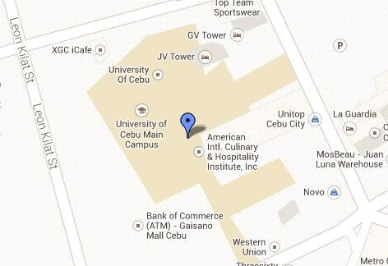

Figure 1.1 Research Environment Location Map

Figure 1.1 Sanciangko Street Cebu City 6000, Philippines Location Map of University of Cebu – Main Campus, 4th Floor Computer Engineering Department UC3 Office.

**RESEARCH PROCEDURES**

**Research Respondents**

When the team formulated the designed project, the team has already an idea on where the project fits best. The team designed this project based on the problems gathered from the survey and all the information gathered from reliable source.

Determining the sample size of research respondents, the team used the Gay’s standard formula where ten percent (10%) of the total population been used since the team used the descriptive method of the research. With a total population of one thousand nine hundred ninety (1990) from the mentioned research environments sample size of one hundred ninety-nine (199) respondents, compromising of one hundred sixty (160) Computer Engineering students and thirty nine (39) Information Technology students.

Table 1

**Total Population and Respondents**

|  |  |  |
| --- | --- | --- |
| Respondents | Number of Population | Respondents Needed (10%) |
| Computer Engineering | 394 | 39 |
| Information Technology | 1596 | 160 |
| Total Population | 1990 | 199 |

This table shows the number of total population of respondents needed in the Computer Engineering and Information Technology departments. The Computer Engineering respondents out of three hundred ninety-four is only thirty-nine. Information Technology respondents out of one thousand five hundred ninety-six is only one hundred sixty. This shows only the ten percent of the population of respondents of the study.

**Research Instrument**

Hence, in this project study, the team used the descriptive method of research by means of conducting a survey using the questionnaire as a guiding tool. The survey questionnaire has ten important questions to be given to the respondents in order to get some input and procedures. The data gathered will be of great help in the accomplishment of the project study.

**Gathering of Data**

The team sought the permission of the Dean. After the approval, the team distributed the questionnaire to the respondents. After giving the survey to the respondents, the results will be gathered and collated to find out the different perspectives of the respondents regarding the study.

**Treatment of Data**

In order to give an in-depth analysis and interpretation to the study, the responses of the respondents will be subjected to statistical treatment with the use of the different statistical tools.

This is the statistical treatment that is used to determine the profile of the respondents were as follows.

P = F/n X 100

where:

*P* = percentage

*F* = frequency

*n* = no. of respondents (from the sample size)

This ensures that the statistical conclusions will be valid.

*n* =

where:

*n* = sample size

*N* = population size

*e* = desired margin of error

To illustrate:

*n =*  *n =*

where:

n = 100

N = 1000

e = 10%

**Definition of Terms**

For further understanding, the following terms or words are defined since these are commonly used in this research paper.

Block Diagram

* A chart of computer or other system in which labeled blocks are used to represent the components, lines and arrows show the pathway and relationship among the elements.

Broadband

* A device that comprises a wide range of frequencies.

Feature

* This unique, attractive, or desirable property of a program or of a computer or other hardware.

Flowchart

* A diagram representing the logical sequence in which a combination of steps or operation is to be perform.

Hardware

* The physical components of a computer system, including any peripheral equipment such as printers, modem and mouse.

I/O Devices

* These are the devices used in the output of the microcontroller.

Internet

* An electronic communications network that connects computer networks and organizational computer facilities around the world.

Microcontroller

* A highly integrated chip which contains all the components compromising a controller.

Program Flowchart

* This describes graphically in detail the logical operation and steps with in a program and the sequence in which these steps are to be executed to the transformation of data to produce the needed output.

Project Design

* A project that is being put into reality by a group of designer.

Router

* A device that mediates the transmission routes of data packets over an electronic communications network (as the internet).

Serial Communication

* This is the process of sending data one bit at one time, sequentially, over a communication channel or computer bus. This is in contrast to parallel communication, where all the bits of each symbols are sent together.

Server

* A computer system that consists of database and other information or a device that manages network resource.

Software

* This refers to computer programs.

System Flowchart

* A graphic representation of the procedure involved in converting data or media to data in output form.

Team

* A team of individuals that is tasked to develop or to make the project design.

Wireless Fidelity (Wi-Fi)

* This is used to certify the interoperability of wireless computer networking devices

**ORGANIZATION OF THE STUDY**

This study is composing of four chapters. The first chapter is “The Problem and Its Scope” which gave an overview of the study and introduced the study and explained the problem at hand. The second chapter is “Presentation, Analysis & Interpretation of Data” which shows the method used, analysis and result of the gathered data during the survey. In this chapter, the data gathered were analyzed and explained. The third chapter is “Technical Aspect of the System” which shows the list of the given features of the project as well as the hardware and software resources used. It is also shown in this chapter the block diagram, program flowchart, source code, and system flowchart to show the flow of the system. The last chapter, which is the “Summary, Findings, Conclusions and Recommendations”,deals with the summary and findings of the study, the conclusion drawn from the data gathered and the recommendations that the team suggested.

**CHAPTER 2**

**PRESENTATION, ANALYSIS & INTERPRETATION OF DATA**

This chapter deals with the results of surveyed questionnaire. The questionnaires consist of eight questions for the students. Each selection of each question is being tabulated and is interpreted by the team to formulate a conclusion for the project design. It helps the team to know further and understand the problems that will be encountered during the connection of the internet. Furthermore, it also serves as guidelines for the team to follow in building and developing the project design.

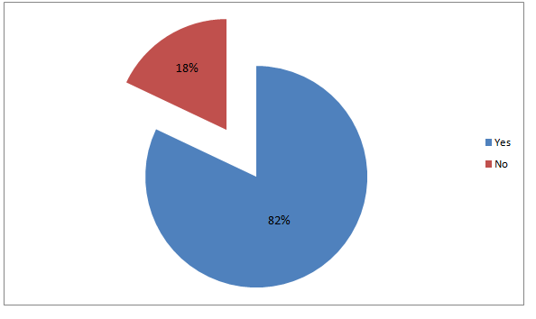

Figure 2.1. Do you have an Internet connection?

The figure shows that 82% of the total respondents have an Internet connection. However, there were 18% of them do not have. This means that the student rely on the school’s facilities for their internet activities.

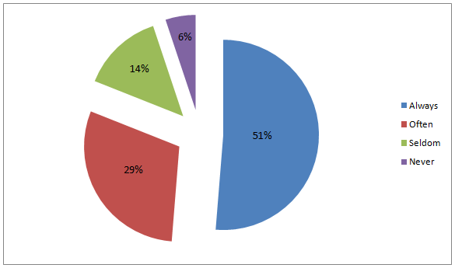

Figure 2.2. How often do you use this connection?

The figure shows that 51% of the total respondents always use internet connection. However, 29% use it often, 14% use it seldom and 6% never use it. Of the 51% users, 29% use it often, 14% use it seldom and 6% never use at all. The figure indicates that students badly needed internet connection.

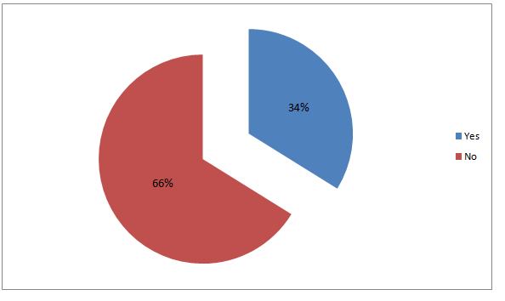

Figure 2.3. Are you satisfied with the performance or speed of your connection?

The figure shows that 66% of the total respondents are not satisfied with the performance of their connection. Only, 34% of them are satisfied. The figure showed that internet connections are not servicing the students well.

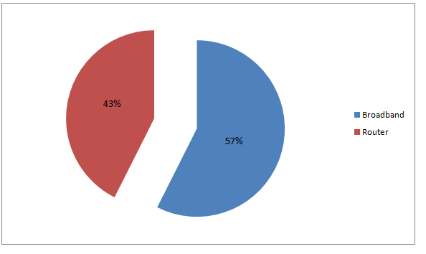

Figure 2.4. What type of device do you use?

The figure shows that 57% of the total respondents used broadband. While others, 43% used router. This indicates the internet users are using broadband connection, more often, as compared to router.

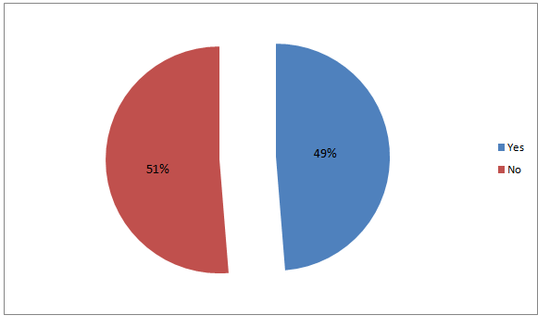

Figure 2.5.Do you have passkey or password in your Wi-Fi connection?

The figure shows that 49% of the total respondents have passwords in their Wi-Fi connection. 51% of them do not have password. This is an indication of internet connection is limited to avoid network log.

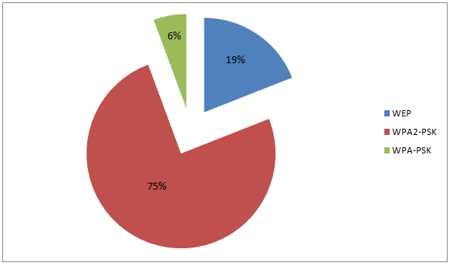

Figure 2.6. If yes, what security type do you have?

The figure shows that 75% of the total respondents used security type WPA2-PSK as their protection for their connection. Only, 19% used WEP and 6% used WPA-PSK. This means that owners of router used the updated type to avoid unknown users connecting to internet without permissions. At the same time, checking and rechecking unknown users of internet.

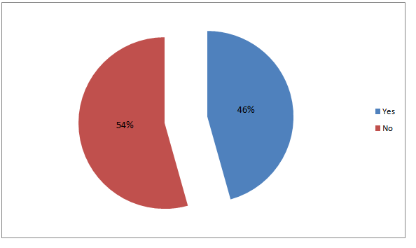

Figure 2.7. Do you have problems in connecting to a private Wi-Fi?

The figure shows that 46% of the total respondents have problems in connecting to a private Wi-Fi, while, 54% of them do not have problems. Some of the respondents who answered yes wrote that their problem in connecting private Wi-Fi it has a password and they also cannot access without password. This only shows that owners really post some security measures to the internet connection.

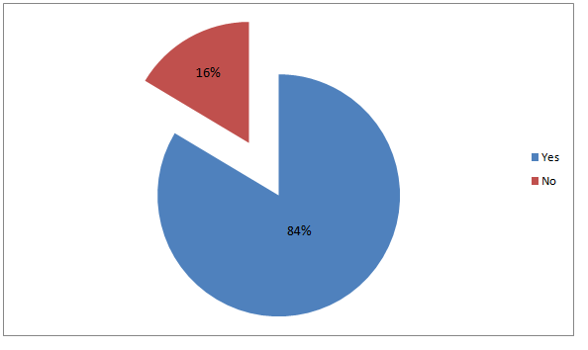

Figure 2.8.Are you in favor to have Coin Operated Wi-Fi in school?

The figure shows that 84% of the respondents are in favor to have Coin Operated Wi-Fi in school while 16% of them are not in favor. This might be an assumption that they users are using broadband.

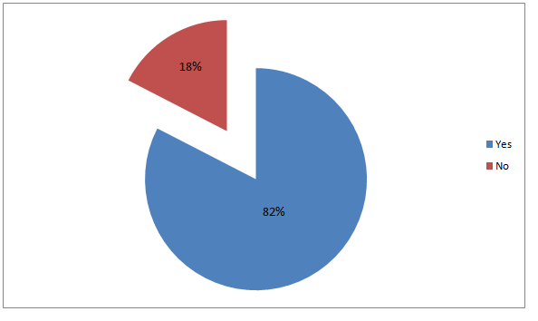

Figure 2.9. Can you benefit from this Coin Operated Wi-Fi if the school has this?

The figure shows that 82% of the respondents said that they can benefit from the project Coin Operated Wi-Fi and 18% said that they cannot benefit from it. This is an indication for the need of it since not all can avail a broadband. A coin operated WI-FI will give them an idea the amount of money incurred from a given time frame.

**CHAPTER 3**

**TECHNICAL ASPECT OF THE SYSTEM**

This chapter deals with the technical aspect of the system. The project’s features are as follows:

* Print Receipt for Transactions and code
* Offers Daily, Weekly and Monthly
* Reprint Transactions
* Touch-screen
* Accepts Php1, Php5, Php10 coins
* Range 20-30 meters
* Remote Access of the server

**Hardware Resources**

System Unit

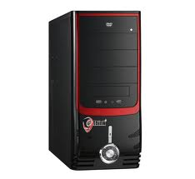

Figure 3.1 System Unit

(http://www.clickbd.com)

The system unit is the main part of a desktop computer. It includes the [motherboard](http://www.techterms.com/definition/motherboard), [CPU](http://www.techterms.com/definition/cpu), [RAM](http://www.techterms.com/definition/ram), and other [components](http://www.techterms.com/definition/component). The system unit also includes the case that houses the internal components of the computer.

Coin detector

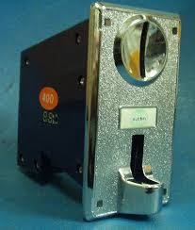

Figure 3.2 Coin detector

(http://www.hiwtc.com/)

A coin detector is a device that determines whether [bills](http://en.wikipedia.org/wiki/Banknote) or [coins](http://en.wikipedia.org/wiki/Coin) are genuine or [counterfeit](http://en.wikipedia.org/wiki/Counterfeit). These devices are used in many automated machines found in [retail kiosks](http://en.wikipedia.org/w/index.php?title=Retail_kiosk&action=edit&redlink=1), [self checkout machines](http://en.wikipedia.org/wiki/Self_checkout_machine), [gaming machines](http://en.wikipedia.org/wiki/Gaming_machine), transportation parking machines, [automatic fare collection machines](http://en.wikipedia.org/wiki/Automated_fare_collection_system), and [vending machines](http://en.wikipedia.org/wiki/Vending_machine).

The process involves examining the currency that has been inserted, and by using various tests, determining if the currency is counterfeit. Since the parameters are different for each [coin](http://en.wikipedia.org/wiki/Coin) or [bill](http://en.wikipedia.org/wiki/Paper_money), these detectors must be programmed for each item that they are to accept.

Router



Figure 3.3 Router

(http://www.4g-store.com/)

A router is a device that forwards [data packets](http://en.wikipedia.org/wiki/Data_packet) between [computer networks](http://en.wikipedia.org/wiki/Computer_network), creating an overlay [internetwork](http://en.wikipedia.org/wiki/Internetwork). A router is connected to two or more data lines from different networks. When a data packet comes in one of the lines, the router reads the address information in the packet to determine its ultimate destination. Then, using information in its [routing table](http://en.wikipedia.org/wiki/Routing_table) or [routing policy](http://en.wikipedia.org/wiki/Routing_policy), it directs the packet to the next network on its journey. Routers perform the "traffic directing" functions on the [Internet](http://en.wikipedia.org/wiki/Internet). A data packet is typically forwarded from one router to another through the networks that constitute the internetwork until it reaches its destination node.

Access Point

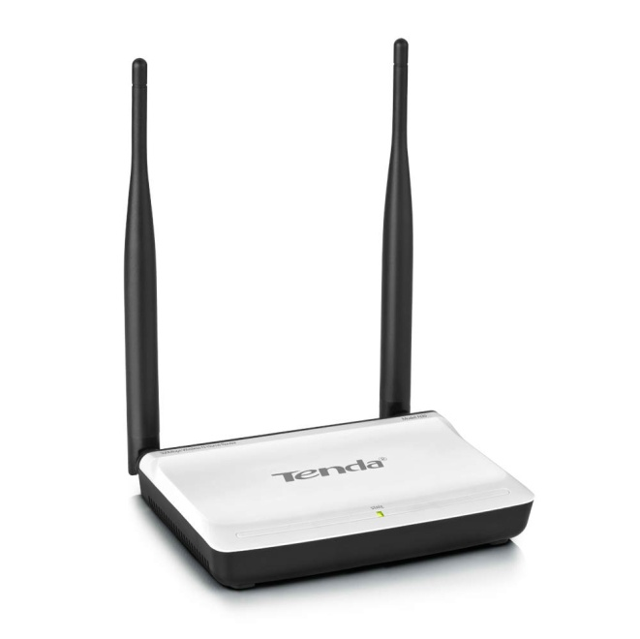

Figure 3.4 Access Point

(http://www.whygomarket.com/)

  A wireless access point (AP) is a device that allows wireless devices to connect to a wired network using [Wi-Fi](http://en.wikipedia.org/wiki/Wi-Fi), or related standards. The AP usually connects to a [router](http://en.wikipedia.org/wiki/Router_(computing)) (via a wired network) as a standalone device, but it can also be an integral component of the router itself.

Thermal Printer

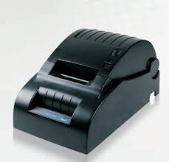

Figure 3.5 Thermal Printer

(http://www.kxpossystem.com/)

Thermal printer is a printer that uses heat to transfer an impression onto paper. Thermal printing is a [digital printing](http://en.wikipedia.org/wiki/Digital_printing) process which produces a printed image by selectively heating coated [thermo chromic paper](http://en.wikipedia.org/wiki/Thermochromic_paper), or [thermal paper](http://en.wikipedia.org/wiki/Thermal_paper) as it is commonly known, when the paper passes over the thermal [print head](http://en.wikipedia.org/wiki/Print_head). The coating turns [black](http://en.wikipedia.org/wiki/Black) in the areas where it is heated, producing an image. Two-color direct thermal printers can print both black and an additional [color](http://en.wikipedia.org/wiki/Colour) (often [red](http://en.wikipedia.org/wiki/Red)) by applying [heat](http://en.wikipedia.org/wiki/Heat) at two different [temperatures](http://en.wikipedia.org/wiki/Temperature).

Straight-Through Cable

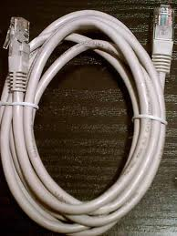

Figure 3.6 Straight-Through Cable

(http://www.bigmech.com/)

Straight-through cable is a type of [twisted pair](http://www.linfo.org/twisted_pair.html) copper wire cable for [local area network](http://www.linfo.org/lan.html) (LAN) use for which the [RJ-45 connectors](http://www.linfo.org/rj-45.html) at each end have the same pin out .It is used to connect computers and other end-user devices to networking devices such as [hubs](http://www.linfo.org/hub.html) and switches. It can also be used to directly connect like devices if the cable is plugged into an [uplink port](http://www.linfo.org/uplink_port.html) on one (but not both) of the devices

Touchscreen Monitor

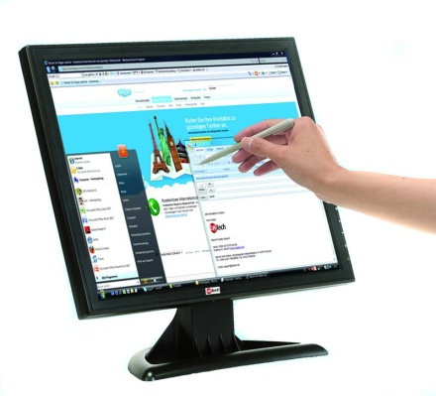

Figure 3.7 Touchscreen Monitor

(http://www.short-circuit.com/)

A touchscreen is an [electronic visual display](http://en.wikipedia.org/wiki/Electronic_visual_display) that the user can control through simple or [multi-touch gestures](http://en.wikipedia.org/wiki/Multi-touch_gestures) by touching the screen with a special stylus/pen and-or one or more fingers. Some touchscreens use ordinary or specially coated gloves to work while others use a special stylus/pen only. The user can use the touchscreen to react to what is displayed and to control how it is displayed.

**Software Resouces**

Microsoft Visual C#



Figure 3.8 Touchscreen Monitor

(http://blogs.msdn.com/)

C# is an [object-oriented](http://www.webopedia.com/TERM/O/object_oriented.html) programming language used with [XML](http://www.webopedia.com/TERM/X/XML.html)-based [Web services](http://www.webopedia.com/TERM/W/Web_services.html) on the [.NET](http://www.webopedia.com/TERM/D/dot_NET.html) platform and designed for improving productivity in the development of Web applications. C# boasts type-safety, garbage collection, simplified type declarations, versioning and scalability support, and other features that make developing solutions faster and easier.

Microsoft Access



Figure 3.9 Microsoft Access

(http://www.personal.psu.edu/)

Microsoft Access, also known as Microsoft Office Access, is a [database management system](http://en.wikipedia.org/wiki/Database_management_system) from [Microsoft](http://en.wikipedia.org/wiki/Microsoft) that combines the [relational](http://en.wikipedia.org/wiki/Relational_database) [Microsoft Jet Database Engine](http://en.wikipedia.org/wiki/Microsoft_Jet_Database_Engine) with a [graphical user interface](http://en.wikipedia.org/wiki/Graphical_user_interface) and software-development tools. It is a member of the [Microsoft Office](http://en.wikipedia.org/wiki/Microsoft_Office) suite of applications, included in the Professional and higher editions or sold separately. It stores data in its own format based on the Access Jet Database Engine. It can also import or link directly to [data](http://en.wikipedia.org/wiki/Data) stored in other applications and databases.

pfSense



Figure 3.10 pfSense

(http://commons.wikimedia.org/)

pfSense is an [open source](http://en.wikipedia.org/wiki/Open-source_software) [firewall](http://en.wikipedia.org/wiki/Firewall_%28computing%29) computer software distribution. It is installed on a computer to make a dedicated firewall for a network and is noted for its reliability and offering features often only found in expensive commercial firewalls. It can be configured and upgraded through a web-based interface. pfSense is commonly deployed as a perimeter firewall, router, [wireless access point](http://en.wikipedia.org/wiki/Wireless_access_point), [DHCP](http://en.wikipedia.org/wiki/DHCP) server, [DNS](http://en.wikipedia.org/wiki/Domain_Name_System) server, and as a [VPN](http://en.wikipedia.org/wiki/VPN) endpoint.

# TeamViewer

# E:\picture DOCU\teamviewer.jpg

# Figure 3.11 TeamViewer

(http://www.netlands.de/)

TeamViewer is a proprietary [computer software](http://en.wikipedia.org/wiki/Computer_software) package for [remote control](http://en.wikipedia.org/wiki/Remote_control_%28computing%29), [desktop sharing](http://en.wikipedia.org/wiki/Desktop_sharing), online meetings, web conferencing and [file transfer](http://en.wikipedia.org/wiki/File_transfer) between computers. The software operates with the [Microsoft Windows](http://en.wikipedia.org/wiki/Microsoft_Windows), [OS X](http://en.wikipedia.org/wiki/OS_X), [Linux](http://en.wikipedia.org/wiki/Linux), [iOS](http://en.wikipedia.org/wiki/IOS_%28Apple%29), [Android](http://en.wikipedia.org/wiki/Android_%28operating_system%29), [Windows RT](http://en.wikipedia.org/wiki/Windows_RT) and [Windows Phone](http://en.wikipedia.org/wiki/Windows_Phone) [operating systems](http://en.wikipedia.org/wiki/Operating_system). It is also possible to access a machine running TeamViewer with a [web browser](http://en.wikipedia.org/wiki/Web_browser). While the main focus of the application is remote control of computers, collaboration and presentation features are included.

VMware 10.0.1



Figure 3.12 VMware 10.0.1

(http://ebookee.org/)

VMware is a type of virtual machine (VM) that is a [software](http://en.wikipedia.org/wiki/Software)-based [emulation](http://en.wikipedia.org/wiki/Emulation) of a computer. Virtual machines operate based on the [computer architecture](http://en.wikipedia.org/wiki/Computer_architecture) and functions of a real or hypothetical computer.

**Function Block Diagram**

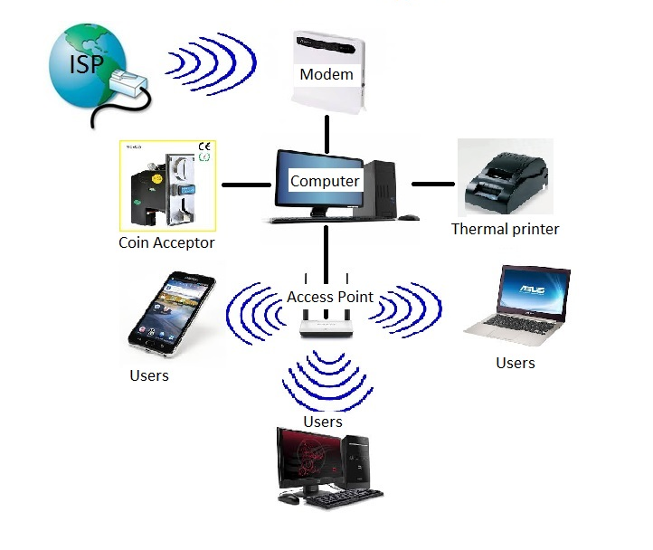

Figure 3.13 Function Block Diagram

The function block diagram shows a schematic flow of the general arrangement of the parts of the team’s project. Getting signal from the internet service provider to the modem. The modem distributes the internet data to the computer. In turn, the signals are used by the users.

**Program Flowchart**

The following figures show the flow of the program in the system.

Figure 3.13 Program Flowchart



Figure 3.14 Program Flowchart (Continued)



Figure 3.15 Program Flowchart (Continued)



Figure 3.16 Program Flowchart (Continued)



Figure 3.17 Program Flowchart (Continued)

**Database Diagram**

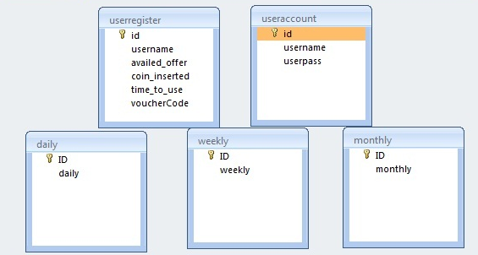

Figure 3.18 Database Diagram

The figure shows that the systems database consist of userregister, useraccount, daily, weekly and monthly. The userregister is where the data inputted by the user and stored. The useraccount is where the account of the admin with username and userpass. The purpose of this database is to see the users who registered in the system. The daily, weekly, monthly databases are where the data of the codes were stored according to the time length of the following databases.

**CHAPTER 4**

**SUMMARY, FINDINGS, CONCLUSIONS AND RECOMMENDATIONS**

This chapter deals with the summary and findings of the study, the conclusion drawn from the data gathered and the recommendations.

**SUMMARY**

This study aimed to present a new system that will help students in the University of Cebu to connect to a Wi-Fi with faster internet connection, hustle free and less charge.

Specifically, this study aimed to answer the questions about what are the common problems encountered when connecting to a private wireless local area network. What common types of internet connecting devices used in wireless local area network that has a great necessity of internet connection to the public.

To gather some necessary information what benefits their project may give the team conducted a survey for the purpose of knowing the feedback of the students and their suggestions regarding the proposed project. The team conducted the survey at Sanciangko Street Cebu City, University of Cebu – Main Campus, 4th floor Computer Engineering Department and 5th floor Information Technology Department with one hundred ninety nine respondents.

**FINDINGS**

After the data were gathered, analyzed, and interpreted. The team found out that most of the students do have internet connections. However, it is a necessary and indispensable medium. They are also not satisfied with the performance and its speed of it. These factors greatly affect the convenience of the user. The common device to connect to the internet is either broadband or wireless router. To have devices like these, they need to buy it or subscribe to an internet provider. Most students use these devices to connect to the internet and they will not go outside the campus anymore. The internet is a great necessity to the public specially students who research and find knowledge to cope with their academic needs in the school.

**CONCLUSION**

Based on the findings of the study, the team concluded that connecting Wi-Fi have issues in catering to the needs of the users. They cannot connect when there is password or when get connected but the speed is slow. They go to the internet provider to have a plan or buy devices with a higher cost just to connect to the internet.

The team concluded that developing “Coin Operated Wi-Fi” can make the users satisfied in the performance of their connection with given password and less cost, making it more convenient.

**RECOMMENDATION**

Technology is developing fast in business where the needs of consumers constantly change. The team must have such knowledge in familiarizing the characteristics of the components, seeing to it that the components are reliable and such components could give the exact data to maximize the capability of the system. The team suggested that testing the system is necessary from time to time if there is a module being accomplished. The team also recommends to the future team that doing more research could bring out a lot of ideas. The system’s capability can be modified to meet the new demands of the customer and therefore increases its marketability. To the future developers, the team highly recommends adding up a bill acceptor. With this, problems regarding coins will be reduced. Through the use of the technology and some marketing techniques, the system could be well developed and be enhanced for greater customer satisfaction.

**BIBLIOGRAPHY**

**A. Published Books**

Imar Spaanjaars, Beginning ASP.NET 4.5.1: in C# and VB , March 2014.H.M. Deitel, P.J Deitel and T.R. Nieto. Internet & World Wide Web: How To Program, Second Edition.

Mark Dye, Rick McDonald and Antoon Rufi. Network Fundamentals: CCNA Exploration Companion Guide, Low Price Edition.

Eric Geier. Wi-Fi Hotspots: Setting Up Public Wireless Internet Access

Forouzan, Behrouz and Firouz Mosharraf. COMPUTER NETWORKS: A TOPDOWN APPROACH. International Edition, 2012.

**B. Unpublished Books**

Facundo, Lloyd Ivon Mark and Mellomar Otarra. “Courtesy Booth Robot Attendant.” Unpublished Bachelor of Science in Computer Engineering thesis, University of Cebu, Cebu City, 2009.

Mascariñas, Francis Moniño and Kenneth Tanudtud. “Paperless Ticketing System”. Unpublished Bachelor of Science in Computer Engineering thesis, University of Cebu, Cebu City, 2012.

Coronel, David Melicor and Walsh Sotto. “GSM – BASED PAYPHONE FOR MOBILE PHONE COMMUNICATION”. Unpublished Bachelor of Science in Computer Engineering thesis, University of Cebu, Cebu City, 2013.

**C. ON-LINE RESOURCES**

http://ebookee.org/

http://www.netlands.de/

http://en.wikipedia.org/wiki/Routing

http://blogs.msdn.com/

http://www.short-circuit.com/

http://www.bigmech.com/

http://www.whygomarket.com/

http://www.4g-store.com/

http://www.hiwtc.com/

http://www.clickbd.com

<http://en.wikipedia.org/wiki/Database_theory>

<http://www.environment.gen.tr/general-systems-theory/137-what-is-systems-theory.html>

<http://toc.csail.mit.edu/?q=index>

http://en.wikipedia.org/wiki/Routing

**APPENDICES**

**APPENDIX A**

**Transmittal Letter**

August 12, 2013

Dear Sir/Madam:

Good day!

We are 5th year students from the Computer Engineering Department of the University of Cebu – Main Campus currently taking up the subject Research. In connection with this we would like to ask your kind approval to allow us to conduct a survey in your department regarding the students knowledge about internet connection. The information that will be gathered will serve as basis for our research and will be beneficial to us and the students. Rest assured that all the information gathered are kept confidential.

The team is hoping for your positive response to this very important matter. The success of the team relies on your hands.

Thank you so much.

Very truly yours,

John Reece Colina

Billy Uy

Richard Vergis

Noted by:

Engr. Nenette Alvarez

Project Adviser

**APPENDIX B**

**Transmittal Letter**

October 2, 2013

Mr. Melvin M. Ninal

College of Information and Computer Studies (CICS)

University of Cebu (Main Campus)

Sanciangko St. Cebu City, 6000

August 12, 2013

Dear Sir/Madam:

Good day!

We are 5th year students from the Computer Engineering Department of the University of Cebu – Main Campus currently taking up the subject Research. In connection with this we would like to ask your kind approval to allow us to conduct a survey in your department regarding the students knowledge about internet connection. The information that will be gathered will serve as basis for our research and will be beneficial to us and the students. Rest assured that all the information gathered are kept confidential.

The team is hoping for your positive response to this very important matter. The success of the team relies on your hands.

Thank you so much.

Very truly yours,

John Reece Colina

Billy Uy

Richard Vergis

Noted by:

Engr. Nenette Alvarez

Project Adviser

**APPENDIX C**

**Research Instrument**

Name (Optional):_____________________ Course:____________________

Questionnaire

Please put check to your answer.

1. Do you have Internet connection?

□ Yes □ No

1. How often do you use this connection?

□ Always □ Often □ Seldom □ Never

1. Are you satisfied to the performance or speed of your connection?

□ Yes □ No

1. What type of device do you use?

□ Broadband □ Router

1. Do you have passkey or password in your Wi-Fi connection?

□Yes □No

If yes, what security type do you have?

□WEP □WPA2 - PSK □WPA – PSK

6. Do you have problems in connecting to a private Wi-Fi?

□Yes □No

If yes, what are those problems? _______________________

1. Are you in favor to have Coin Operated Wi-Fi in school?

□ Yes □ No

1. Can you benefit from this Coin Operated Wi-Fi if the school has this?

□ Yes □ No

**APPENDIX D**

**Time Table of Activities**

|  |  |  |  |  |  |  |  |  |  |  |  |  |  |  |  |  |  |  |
| --- | --- | --- | --- | --- | --- | --- | --- | --- | --- | --- | --- | --- | --- | --- | --- | --- | --- | --- |
| **Activities** | **Months** | | | | | | | | | | | | | | | | | |
| **Jul** | | **Aug** | | **Sept** | | **Oct** | | **Nov** | | **Dec** | | **Jan** | | **Feb** | | **Mar** | |
| **A** | **C** | **A** | **C** | **A** | **B** | **A** | **C** | **A** | **B** | **A** | **C** | **A** | **C** | **A** | **B** | **A** | **C** |
| Brain storming for the project proposal |  |  |  |  |  |  |  |  |  |  |  |  |  |  |  |  |  |  |
| Research about the project |  |  |  |  |  |  |  |  |  |  |  |  |  |  |  |  |  |  |
| Gathering of project components |  |  |  |  |  |  |  |  |  |  |  |  |  |  |  |  |  |  |
| Buying the partial components |  |  |  |  |  |  |  |  |  |  |  |  |  |  |  |  |  |  |
| Making the documentation |  |  |  |  |  |  |  |  |  |  |  |  |  |  |  |  |  |  |
| Formulate survey questioners |  |  |  |  |  |  |  |  |  |  |  |  |  |  |  |  |  |  |
| Making the software program |  |  |  |  |  |  |  |  |  |  |  |  |  |  |  |  |  |  |
| Finalize the project |  |  |  |  |  |  |  |  |  |  |  |  |  |  |  |  |  |  |
| Constructing the hardware side |  |  |  |  |  |  |  |  |  |  |  |  |  |  |  |  |  |  |
| Interfacing the software and the hardware |  |  |  |  |  |  |  |  |  |  |  |  |  |  |  |  |  |  |

**Legend: A = 1 to 15 days, B = 15 to 30 days, C = 15 to 31 days**

**APPENDIX E**

**PROGRAM BUDGET**

**Overall Cost of the Project**

|  |  |  |  |
| --- | --- | --- | --- |
| **Item**  **Description** | **Quantity** | **Unit Price** | **Total Price (PHP)** |
| System Unit | **1** | **14,000** | **14,000** |
| Coin detector | **1** | **750** | **750** |
| Modem | **1** | **15,000** | **15,000** |
| Access Point | **1** | **1,000** | **1,000** |
| Thermal Printer | **1** | **2,995** | **2,995** |
| Straight-Through Cable | **1** | **1,000** | **1,000** |
| Touch Screen Monitor | **1** | **9,100** | **9,100** |
| Kiosk | **1** | **3,000** | **3,000** |
| **Total** |  | | **46,845** |